Lakeside Primary Academy VLE overview for week beginning 1/2/2021
Monday 1/2/2021
Spelling | Guided reading  9am Zoom | Maths  10am Zoom | English  11am Zoom | Topic | Other subjects
L.O: Introducing new spellings  Introduce the new word list using the Monday slide on the spelling sheets. Discuss meaning, on the spelling sheets split into syllables and sounds, work together word by word. | L.O: Pre read  This activity asks children to read this text we are focusing on this week then make notes on what they have read.  See the guided reading resources for the activity. | L.O: Multiply decimals by integers  Pupils will learn how to multiply decimals by integers.  Video link to introduce the lesson:  https://vimeo.com/  490690764 | L.O: Cold task  Rescue Story  For this unit, you need to write a story where the main character sets out on a journey and rescues somebody from a perilous situation. | Topic LO: Develop understanding of classification  Pupils learn about how animals are classified and the system that are used to classify them.  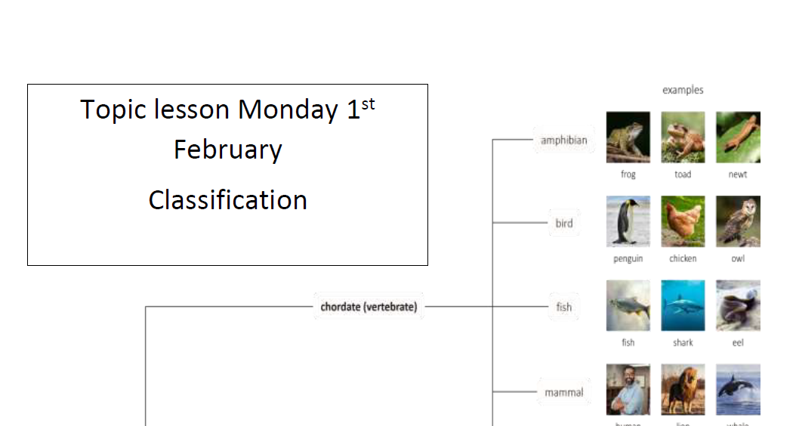
Mrs Deakin and Mrs McKenzie’s group

L.O: Multiply 2-digits by 1-digit

https://vimeo.com/
486513593

Link to Mrs Mathers reading our class book – The Wolf Wilder
Today’s live lessons on Zoom
9am – reading  Zoom link:  See VLE for Zoom links |  | 10am – maths  Zoom link:  See VLE for Zoom links |  | 11am English  Zoom link:  See VLE for Zoom links
Notes for the week:  You can also revise times tables on https://ttrockstars.com/  Additional activities are also provided on  https://mathswithparents.com/  Class: 6RC  Class Code: 300350  Class: 6NW  Class Code: 312591 |  | Notes for the week:  Try to read a book every day. You can find E-Books on www.oxfordowls.com  Complete the reading comprehension on https://readingonyourhead.com/ each week. |  | Notes for the week:

Lakeside Primary Academy VLE overview for week beginning 1/2/2021
Tuesday 2/2/2021
Spelling | Guided reading  9am Zoom | Maths  10am Zoom | English  11am Zoom | Topic | Other subjects
L.O: year 3/4 and Year 5/6 words  Introduce this week’s year three and four words using the Tuesday slide on the spelling sheets. Discuss meaning, use the spelling sheets to split into syllables and sounds, work together word by word. | L.O: Reading activity  This activity asks children to complete an activity based on the text we are reading this week.  See the guided reading resources for the activity. | L.O: Divide decimals by integers  Pupils will learn how to divide decimals by integers  Video link to introduce the lesson:  https://vimeo.com/490691239 | LO – To analyse a text and clarify unknown vocabulary  First, read the text that comes with today’s work then identify unfamiliar words, predict what you think they mean, record their definition from a dictionary and use in your own sentence. | PE: Circuit Set  Complete the following circuit 3 times  5 x Step Ups: Using the bottom step of your stairs.  4 x High Knees: Jumping bring your knees to your chest  3 x Star Jumps Big jump making a star shape with arms and legs  2 x Hops Balance on 1 leg, bend your knee and hop  1 x Balance: Balance on one leg for 30 seconds as your rest period.  Challenge Yourself! Double the number of times you do each one ie. 10 x Step Ups, x8 High Knees etc  Thinking about the changes to your body when you exercise, write three sentences to describe some of the changes that happened when doing the circuit. As an example, you may mention your heart beating faster.
Mrs Deakin and Mrs McKenzie’s group

L.O: Multiply 2 digits by 2 digits

https://vimeo.com/
489850121

Link to Mrs Mathers reading our class book – The Wolf Wilder
Today’s live lessons on Zoom
9am – reading  Zoom link:  See VLE for Zoom links |  | 10am – maths  Zoom link:  See VLE for Zoom links |  | 11am English  Zoom link:  See VLE for Zoom links
Notes for the week:  L.O means learning objective. This is the skill we focus on each day.  You can also revise times tables on https://ttrockstars.com/  Additional activities are also provided on  https://mathswithparents.com/  Class: 6RC  Class Code: 300350  Class: 6NW  Class Code: 312591 |  | Notes for the week:  Try to read a book every day. You can find E-Books on www.oxfordowls.com  Complete the reading comprehension on https://readingonyourhead.com/ each week. |  | Notes for the week:

Lakeside Primary Academy VLE overview for week beginning 1/2/2021
Wednesday 3/2/2021
Spelling | Guided reading  9am Zoom | Maths  10am Zoom | English  11am Zoom | Topic | Other subjects
L.O: independent work  Using the Wednesday slide on the spelling sheets, practice the words independently. It is good to write them in sentences if you are comfortable with the spellings. | L.O: Vocabulary activity  This activity asks children to answer vocabulary questions based on the text we are studying this week.  See the guided reading resources for the activity. | L.O: Division to solve problems  Pupils will learn how to use division to solve problems  Video link to introduce the lesson:  https://vimeo.com/490691954 | LO – To write an effective description  Today pupils are writing a description of an image, with a focus on making their writing as detailed and descriptive as possible. | Topic LO: Develop understanding of classification keys  Pupils learn about how animals are classified using classification keys and use a classification key to classify animals.  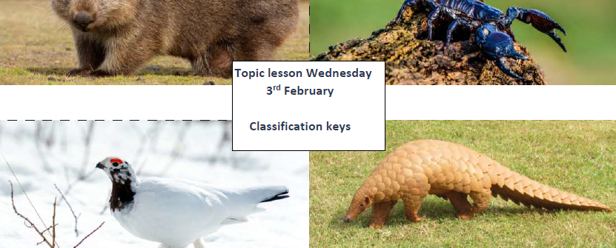
Mrs Deakin and Mrs McKenzie’s group

L.O: Divide 2-digits by 1-digit

https://vimeo.com/
489844871

Link to Mrs Mathers reading our class book – The Wolf Wilder
Today’s live lessons on Zoom
9am – reading  Zoom link:  See VLE for Zoom links |  | 10am – maths  Zoom link:  See VLE for Zoom links |  | 11am English  Zoom link:  See VLE for Zoom links
Notes for the week:  L.O means learning objective. This is the skill we focus on each day.  You can also revise times tables on https://ttrockstars.com/  Additional activities are also provided on  https://mathswithparents.com/  Class: 6RC  Class Code: 300350  Class: 6NW  Class Code: 312591 |  | Notes for the week:  Try to read a book every day. You can find E-Books on www.oxfordowls.com  Complete the reading comprehension on https://readingonyourhead.com/ each week. |  | Notes for the week:

Lakeside Primary Academy VLE overview for week beginning 1/2/2021
Thursday 4/2/2021
Spelling | Guided reading  9am Zoom | Maths  10am Zoom | English  11am Zoom | Topic | Other subjects
L.O: paired work  Today you will need a partner – a parent, sibling or pet if you are struggling. | L.O: Comprehension activity  This activity asks children to answer comprehension questions based on the text we are studying this week.  See the guided reading resources for the activity. | L.O: Decimals as fractions  Pupils will learn how to state decimals as fractions.  Video link to introduce the lesson:  https://vimeo.com/490693175 | LO – To write an effective summary  Pupils write a summary of the model text. | KIXX PE football skills session  All you will need to take part is a football and a little bit of space outside…enjoy!  https://www.youtube.com/watch?v=5U3cLLIP_  Kk&feature=youtu.be
Mrs Deakin and Mrs McKenzie’s group

L.O: Divide 2-digits by 1-digit

https://vimeo.com/
489845622

Today’s live lessons on Zoom
Link to Mrs Mathers reading our class book – The Wolf Wilder
9am – reading  Zoom link:  See VLE for Zoom links |  | 10am – maths  Zoom link:  See VLE for Zoom links |  | 11am English  Zoom link:  See VLE for Zoom links
Notes for the week:  L.O means learning objective. This is the skill we focus on each day.  You can also revise times tables on https://ttrockstars.com/  Additional activities are also provided on  https://mathswithparents.com/  Class: 6RC  Class Code: 300350  Class: 6NW  Class Code: 312591 |  | Notes for the week:  Try to read a book every day. You can find E-Books on www.oxfordowls.com  Complete the reading comprehension on https://readingonyourhead.com/ each week. |  | Notes for the week:

Lakeside Primary Academy VLE overview for week beginning 1/2/2021
Friday 5/2/2021
Spelling | Guided reading  9am Zoom | Maths  10am Zoom | English  11am Zoom | Topic | Other subjects
L.O: spelling test  Ask an adult to test you on this week’s words. | L.O: Marking comprehension activity  This activity asks children to mark the questions they answered yesterday. It is best to do this session with an adult so you can discuss your answers and correct them.  See the guided reading resources for the activity. | L.O: Convert fractions to decimals  Pupils will learn how to convert fractions to decimals  Video link to introduce the lesson:  https://vimeo.com/491237616 | LO – Use correct punctuation for speech  Pupils write a conversation between two characters, focusing on making correct use of direct speech. | Topic LO: Develop understanding of adaptation  Pupils learn about what adaptation is and identify examples in animals.  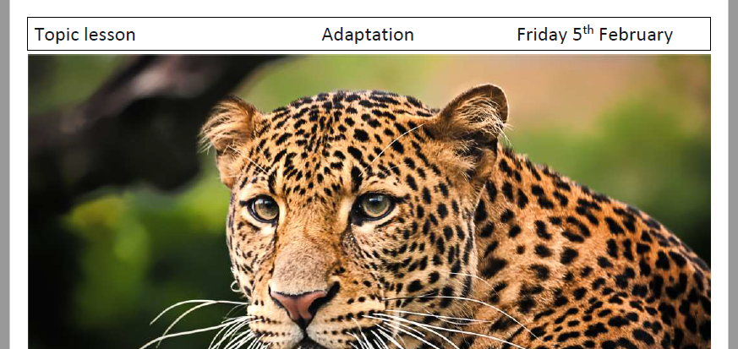
Mrs Deakin and Mrs McKenzie’s group

L.O: Divide 2-digits by 1-digit

https://vimeo.com/
494126561

Today’s live lessons on Zoom
Link to Mrs Mathers reading our class book – The Wolf Wilder
9am – reading  Zoom link:  See VLE for Zoom links |  | 10am – maths  Zoom link:  See VLE for Zoom links |  | 11am English  Zoom link:  See VLE for Zoom links
Notes for the week:  L.O means learning objective. This is the skill we focus on each day.  You can also revise times tables on https://ttrockstars.com/  Additional activities are also provided on  https://mathswithparents.com/  Class: 6RC  Class Code: 300350  Class: 6NW  Class Code: 312591 |  | Notes for the week:  Try to read a book every day. You can find E-Books on www.oxfordowls.com  Complete the reading comprehension on https://readingonyourhead.com/ each week. |  | Notes for the week:

