Tuesday 3rd of February 2021
LO: To write a letter.
Write a letter to the Queen, telling her that you have been learning all about London and that you know lots of interesting facts.
You could maybe even ask her some questions about what it is like to be the Queen.
Make sure that you are using your neatest handwriting, capital letters and full stops. Remember if you are asking some questions you need to use a ?
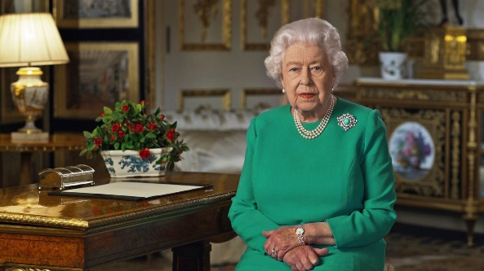
Address:
Her Majesty The Queen
Buckingham Palace
London

