Lakeside Primary Academy VLE overview for week beginning 25/1/2021
Monday 25/1/2021
Spelling | Guided reading  9am Zoom | Maths  10am Zoom | English  11am Zoom | Topic | Other subjects
L.O: Introducing new spellings  Introduce the new word list using the Monday slide on the spelling sheets. Discuss meaning, on the spelling sheets split into syllables and sounds, work together word by word. | L.O: Pre read  This activity asks children to read this text we are focusing on this week then make notes on what they have read.  See the guided reading resources for the activity. | L.O: Decimals up to 2 d.p.  A session to remind pupils of learning they have covered previously for decimals with up to 2 decimal places.  Video link to introduce the lesson:  https://vimeo.com/  485432781 | L.O: Look at page 1 of the ‘Winter’ booklet.  Today we are looking at synonyms for wintery words. Remember to use a dictionary for any unfamiliar words to find the exact meaning – these will come in handy later in the week! | PE: Circuit Set  Complete the following circuit 3 times  5 x Step Ups: Using the bottom step of your stairs.  4 x High Knees: Jumping bring your knees to your chest  3 x Star Jumps Big jump making a star shape with arms and legs  2 x Hops Balance on 1 leg, bend your knee and hop  1 x Balance: Balance on one leg for 30 seconds as your rest period.  Challenge Yourself! Double the number of times you do each one ie. 10 x Step Ups, x8 High Knees etc  Thinking about the changes to your body when you exercise, write three sentences to describe some of the changes that happened when doing the circuit. As an example, you may mention your heart beating faster.
Mrs Deakin and Mrs McKenzie’s group

L.O: 9 times table division facts

Link to Mrs Mathers reading our class book – The Wolf Wilder https://LakesidePrimaryAcademy.screencasthost.com/watch/crVb2p9jMP
Today’s live lessons on Zoom
9am – reading  Zoom link:  Login to the VLE for today’s Zoom links. |  | 10am – maths  Zoom link:  Login to the VLE for today’s Zoom links. |  | 11am English  Zoom link:  Login to the VLE for today’s Zoom links.
Notes for the week:  You can also revise times tables on https://ttrockstars.com/  Additional activities are also provided on  https://mathswithparents.com/  Class: 6RC  Class Code: 300350  Class: 6NW  Class Code: 312591 |  | Notes for the week:  Try to read a book every day. You can find E-Books on www.oxfordowls.com  Complete the reading comprehension on https://readingonyourhead.com/ each week. |  | Notes for the week:

Lakeside Primary Academy VLE overview for week beginning 25/1/2021
Tuesday 26/1/2021
Spelling | Guided reading  9am Zoom | Maths  10am Zoom | English  11am Zoom | Topic | Other subjects
L.O: year 3/4 and Year 5/6 words  Introduce this week’s year three and four words using the Tuesday slide on the spelling sheets. Discuss meaning, use the spelling sheets to split into syllables and sounds, work together word by word. | L.O: Reading activity  This activity asks children to complete an activity based on the text we are reading this week.  See the guided reading resources for the activity. | L.O: Understand thousandths  Pupils will develop their understanding of thousandths.  Video link to introduce the lesson:  https://vimeo.com/  485550430 | L.O Read the poem ‘Picture books in winter’ by Robert Louis Stevenson. Now answer the questions that go with it. Are there any unfamiliar words you need to clarify? If so, predict their meaning and then confirm or correct using a dictionary.. | L.O Exploring what causes climate change  Pupils read a climate change blog and then answer questions on it:  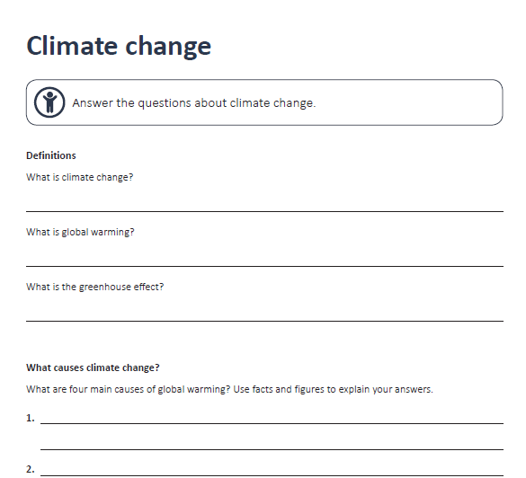
Mrs Deakin and Mrs McKenzie’s group

L.O: Multiply and divide by 7

Link to Mrs Mathers reading our class book – The Wolf Wilder https://LakesidePrimaryAcademy.screencasthost.com/watch/crVboq9jRb
Today’s live lessons on Zoom
9am – reading  Zoom link:  Login to the VLE for today’s Zoom links. |  | 10am – maths  Zoom link:  Login to the VLE for today’s Zoom links. |  | 11am English  Zoom link:  Login to the VLE for today’s Zoom links.
Notes for the week:  L.O means learning objective. This is the skill we focus on each day.  You can also revise times tables on https://ttrockstars.com/  Additional activities are also provided on  https://mathswithparents.com/  Class: 6RC  Class Code: 300350  Class: 6NW  Class Code: 312591 |  | Notes for the week:  Try to read a book every day. You can find E-Books on www.oxfordowls.com  Complete the reading comprehension on https://readingonyourhead.com/ each week. |  | Notes for the week:

Lakeside Primary Academy VLE overview for week beginning 25/1/2021
Wednesday 27/1/2021
Spelling | Guided reading  9am Zoom | Maths  10am Zoom | English  11am Zoom | Topic | Other subjects
L.O: independent work  Using the Wednesday slide on the spelling sheets, practice the words independently. It is good to write them in sentences if you are comfortable with the spellings. | L.O: Vocabulary activity  This activity asks children to answer vocabulary questions based on the text we are studying this week.  See the guided reading resources for the activity. | L.O: Three decimal places  Pupils will develop their understanding of numbers with up to 3 decimal places.  Video link to introduce the lesson:  https://vimeo.com/  487196408 | L.O: Today we are looking at writing sentences which are active or passive - A sentence is written in active voice when the subject of the sentence is performing the action.  A sentence is written in passive voice when the subject of the sentence has something done to it by someone or something. Using the images on page 4, write your own active or passive sentences. | Introducing Get Set Tokyo  To celebrate the upcoming Tokyo Olympics Miss Clarke has signed up to take part in a fantastic competition which challenges us to get moving and walk/cycle/run as far as we can. To get started and log your first activity use the links below:  The website is pretty simple to use but video below shows how to log an activity  https://www.getset.co.uk/resources/how-to-log-activity  This is the link to our school page:  https://www.getset.co.uk/travel-tokyo/school/lakeside-primary-school-dn4-5es?schoolSlug=lakeside-primary-school-dn4-5es&teamId=undefined
Mrs Deakin and Mrs McKenzie’s group

L.O: 7 times table multiplication and division facts

Link to Mrs Mathers reading our class book – The Wolf Wilder https://LakesidePrimaryAcademy.screencasthost.com/watch/crVbDY9QiJ
Today’s live lessons on Zoom
9am – reading  Zoom link:  Login to the VLE for today’s Zoom links. |  | 10am – maths  Zoom link:  Login to the VLE for today’s Zoom links. |  | 11am English  Zoom link:  Login to the VLE for today’s Zoom links.
Notes for the week:  L.O means learning objective. This is the skill we focus on each day.  You can also revise times tables on https://ttrockstars.com/  Additional activities are also provided on  https://mathswithparents.com/  Class: 6RC  Class Code: 300350  Class: 6NW  Class Code: 312591 |  | Notes for the week:  Try to read a book every day. You can find E-Books on www.oxfordowls.com  Complete the reading comprehension on https://readingonyourhead.com/ each week. |  | Notes for the week:

Lakeside Primary Academy VLE overview for week beginning 25/1/2021
Thursday 28/1/2021
Spelling | Guided reading  9am Zoom | Maths  10am Zoom | English  11am Zoom | Topic | Other subjects
L.O: paired work  Today you will need a partner – a parent, sibling or pet if you are struggling. | L.O: Comprehension activity  This activity asks children to answer comprehension questions based on the text we are studying this week.  See the guided reading resources for the activity. | L.O: Multiply by 10, 100 and 1000  Pupils will learn how to multiply by 10, 100 and 1000.  Video link to introduce the lesson:  https://vimeo.com/  487198038 | L.O Using page 5 and 6, write a description of the image through the window. You will see that you are being asked to write 5 sentences, each with a specific focus.  - Use a dash/dashes for parenthesis  - Include a relative clause  - Use a semi-colon to indicate the boundary between independent clause  - Use a passive sentence.  Start with a fronted adverbial.  . | E-safety session 2  https://www.thinkuknow.co.uk/globalassets  /thinkuknow/documents/thinkuknow/parents  /pdf/thinkuknow-8-10s-home-activity-sheet-3.pdf  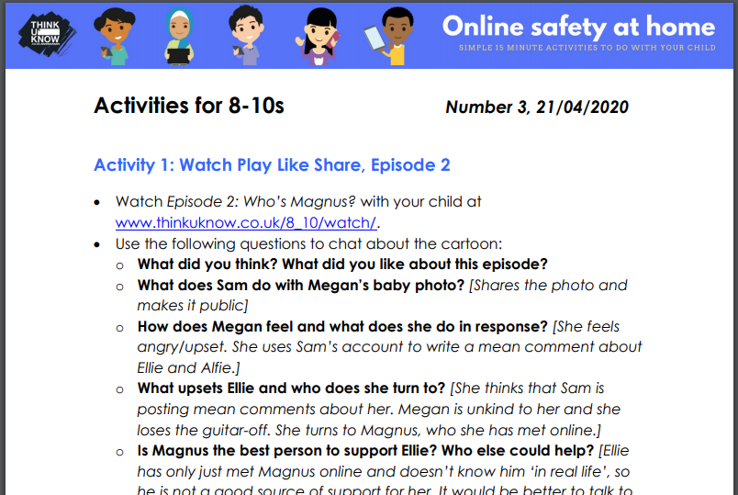
Mrs Deakin and Mrs McKenzie’s group

L.O: Comparing statements

https://vimeo.com/485433674

Today’s live lessons on Zoom
Link to Mrs Mathers reading our class book – The Wolf Wilder https://LakesidePrimaryAcademy.screencasthost.com/watch/crVbbe9Qo3
9am – reading  Zoom link:  Login to the VLE for today’s Zoom links. |  | 10am – maths  Zoom link:  Login to the VLE for today’s Zoom links. |  | 11am English  Zoom link:  Login to the VLE for today’s Zoom links.
Notes for the week:  L.O means learning objective. This is the skill we focus on each day.  You can also revise times tables on https://ttrockstars.com/  Additional activities are also provided on  https://mathswithparents.com/  Class: 6RC  Class Code: 300350  Class: 6NW  Class Code: 312591 |  | Notes for the week:  Try to read a book every day. You can find E-Books on www.oxfordowls.com  Complete the reading comprehension on https://readingonyourhead.com/ each week. |  | Notes for the week:

Lakeside Primary Academy VLE overview for week beginning 25/1/2021
Friday 29/1/2021
Spelling | Guided reading  9am Zoom | Maths  10am Zoom | English  11am Zoom | Topic | Other subjects
L.O: spelling test  Ask an adult to test you on this week’s words. | L.O: Marking comprehension activity  This activity asks children to mark the questions they answered yesterday. It is best to do this session with an adult so you can discuss your answers and correct them.  See the guided reading resources for the activity. | L.O: Divide by 10, 100 and 1000  Pupils will learn how to divide by 10, 100 and 1000.  Video link to introduce the lesson:  https://vimeo.com/  488186549 | L.O: Today you are going to create your own fact file about robins, using the information you have and any further research you choose to do. You can research in books or online – remember to think about the layout. | PE: Different rooms  Hop, skip, JUMP! Can you move around your house only using hopping, skipping and jumping as a method of travelling?  To start, hop to the first room and touch the furthest wall from the door.  Next, skip to the next room and touch the window  Finally, jump to the final room and touch all four walls.  Challenge Yourself! Move around the house only using the hop, skip and jump method  Once you have finished hopping, skipping and jumping around your house try to write a sentence below describing each room you entered. Try to use at least three adjectives in each sentence.
Mrs Deakin and Mrs McKenzie’s group

L.O: Related calculations

https://vimeo.com
/486330232

Today’s live lessons on Zoom
Link to Mrs Mathers reading our class book – The Wolf Wilder https://LakesidePrimaryAcademy.screencasthost.com/watch/crVbbr9QFH
9am – reading  Zoom link:  Login to the VLE for today’s Zoom links. |  | 10am – maths  Zoom link:  Login to the VLE for today’s Zoom links. |  | 11am English  Zoom link:  Login to the VLE for today’s Zoom links.
Notes for the week:  L.O means learning objective. This is the skill we focus on each day.  You can also revise times tables on https://ttrockstars.com/  Additional activities are also provided on  https://mathswithparents.com/  Class: 6RC  Class Code: 300350  Class: 6NW  Class Code: 312591 |  | Notes for the week:  Try to read a book every day. You can find E-Books on www.oxfordowls.com  Complete the reading comprehension on https://readingonyourhead.com/ each week. |  | Notes for the week:

