Remote learning offer 2020- 2021

Since the start of the period of school closure in March 2020 there has been an increased focus on remote education at Lakeside Primary Academy, since then a wide range of approaches have been developed, evaluated and refined. Remote education has made a significant contribution to enabling our children to learn and progress. It is important that we continue to build on the remote learning we can provide during this time and make sure that our children are not missing out on learning as we continue to face periods where children or staff may not be able to attend school.

This work is also important as we look to the long term. Our vision is that we will build a platform that will enable children to access learning at home and at school, supporting them with any extra learning they need to do in areas they are finding difficult or supporting them in the completion of their homework, making learning a shared experience between home and school.

What does the government say about remote learning?

The government recognises the importance of children continuing with their education during periods of time at home as a result of COVID-19. As of the 22nd October 2020, schools are legally required to ensure that children have immediate access to high quality home learning from the first day of absence relating to COVID-

- Parents are required to ensure that children carry out the same amount of core learning as they would in school unless they are ill. At Crowle Primary Academy we expect children to work for at least 4 hours each day whilst at home for a COVID-19 related absence.

What makes Remote Education provision successful?

Research shows that good quality remote education needs to contain a number of features which can also been seen in effective classroom teaching.

These include:
- ensuring children receive clear explanations

- supporting children to become more confident with new learning through demonstrating and supporting them to work through it

- the chance to use new knowledge or skills
- enabling children to receive feedback on how to get better

It is therefore key to our Remote Education provision that we build these principles into our offer for your children.

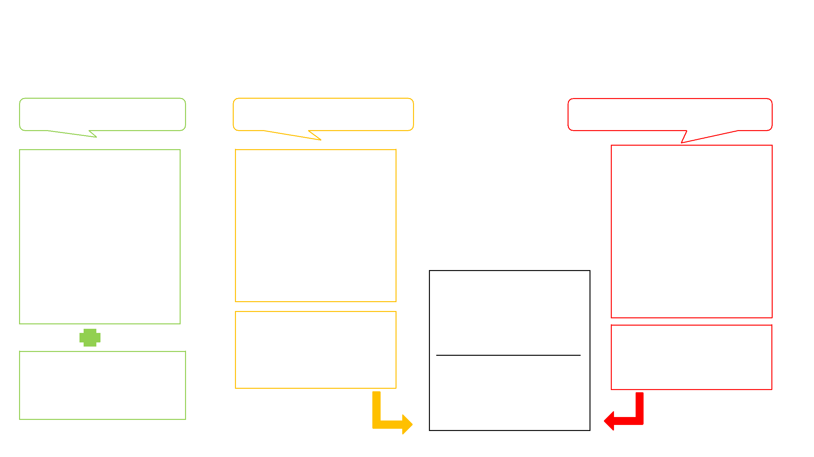
What is our Remote Education offer for your child?

There are a number of circumstances where your child may need to isolate at home which means that we have put in place a remote education offer that will ensure your child has access to high quality learning opportunities from their first day of a COVID-19 related absence. These systems will be particularly important to enable us to manage when the challenges of remote education are greatest, for example where large numbers of pupils are required to remain at home. Below you will find information on what learning your child will be expected to do at home in each of these circumstances.

My child is currently able to attend

school

My child needs to isolate at home, but

their bubble remains at school and my

child is well enough to learn

My child and their bubble need to isolate at

home and my child is well enough to learn

Direct teaching

This is the learning your child will access in school where we have a specific plan for each phase. It includes changes to the normal school day and its structure to support us in carrying out the requirements of our COVID-19 risk assessment. As well as our usual curriculum, there will be a strong focus on the recovery curriculum which supports our children to adjust to being back at school following school closure last year and covers lost learning from the partial school closure. closure.

Home learning

Completion of their homework activities such as reading, learning spelling and tables practise (expectations for this will depend on the year group your child is in)

Home learning plans

On the day that you inform us that your child has to self-isolate you will be sent a home learning plan to your email address. This plan follows the same lessons as the children are
getting that are attending school. It is vital that your child completes these so that they are not behind their classmates when they return to school. closure.

Feedback

On each plan will be details of how the

work your child completes can be submitted for feedback from the teacher. As the teacher will still be teaching full time this feedback may take a little bit of time. closure.

Support from school

During the time that your child is isolating we will call to offer our support. This will usually be day 2 of the first week. If you need any more support, please email admin@lakeside.doncaster.sch.uk
If you have indicated that your child does not have their own device to work on, we will speak to you and offer a loan of a school device. A loan agreement will need to be completed and returned to the school office.

Bubble remote learning

On the day that the bubble is closed you will be sent a home learning plan to your email address. The home learning plans will also be available on the VLE of the school website. It is
vital that your child completes these
so that they are not behind their classmates when they return to school.

When the whole bubble is off teachers

may also prepare video lessons or deliver live lessons depending on the year group and the requirements of the learning set .

Feedback

On each plan will be details of how the

work your child completes can be submitted for feedback from the teacher..

Home learning for a whole bubble closure

Plans are available on the virtual learning environment of our school website

On a computer or laptop

Ask your child/ support your child to log in to the pupil area using their log in details and the verification code (these will be in the back of their home school liaison book).

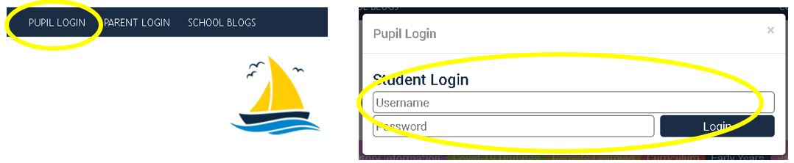

In the homework tab you will find the home learning plan for the week. There will also be individual tasks where completed learning can be uploaded.
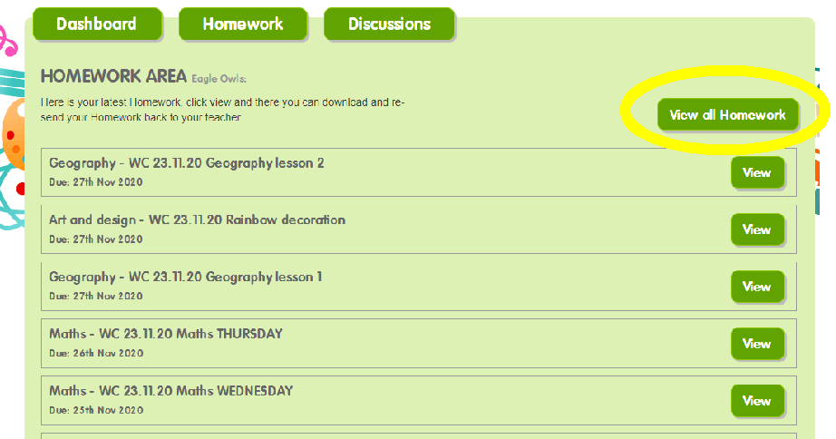

Your child can complete and upload their learning on here or can make a comment about the activity. Remember, comments can be seen by the whole class but uploads are only seen by the teacher. Only one piece of learning can be uploaded, if there are several pieces why not try making a video of all the learning and upload this?

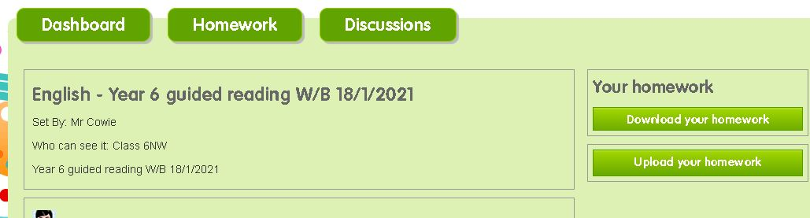

Other activities may be set using different online areas (for example Purple Mash) and work can be shared as instructed and teachers can provide feedback on this platform.

Home learning for a whole bubble closure

Plans are available on the virtual learning environment of our school website

Your child can complete and upload their learning on here or can make a comment about the activity. Remember, comments can be seen by the whole class but uploads are only seen by the teacher. Only one piece of learning can be uploaded, if there are several pieces why not try making a video of all the learning and upload this?

Other activities may be set using different websites(for example Purple Mash) and work can be shared as instructed and teachers can provide feedback on this

platform.

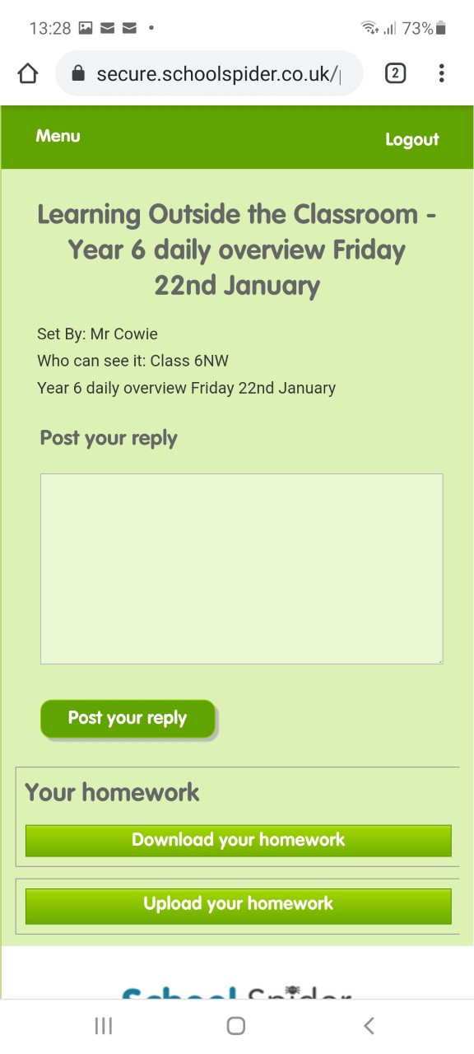
In the homework tab you will find the home learning plan for the week. There will also be individual tasks where completed learning can be uploaded.

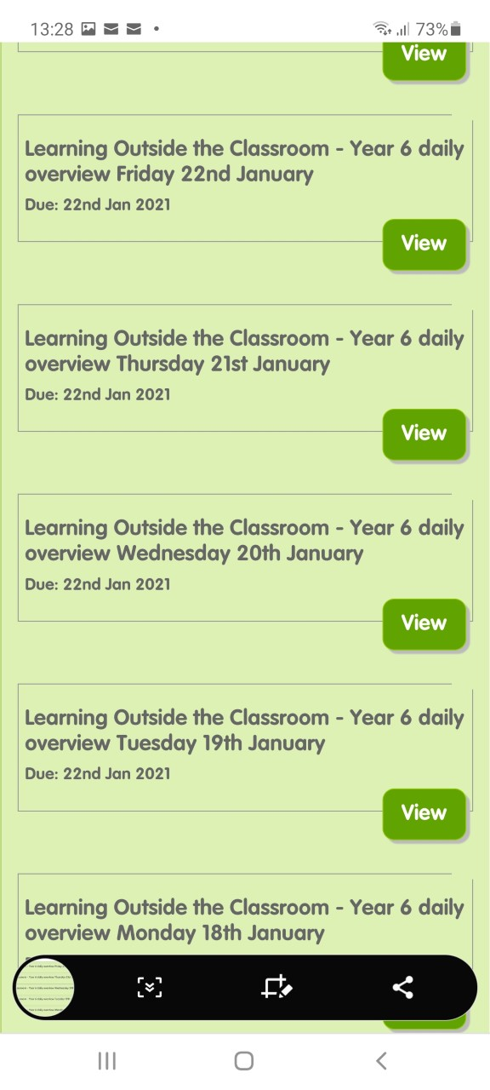

On an iPad/ tablet/mobile phone

Ask your child/ support your child to log in to the pupil area using
their log in details and the verification code (these will be in the
back of their home school liaison book).

Login by navigating to the bottom of our website:

Remote learning overviews for periods of self-isolation (when the whole bubble has not been closed)

The remote learning overview will be uploaded to our remote learning weekly guide pages. Please note these documents will not contain links to live teaching via Zoom for safeguarding reasons.

Daily homework with the Zoom links pupils need will be uploaded to the VLE.

The completed work should be uploaded as homework on the VLE. It is easiest to upload photographs of work.

We may set work using other websites like Times table rock stars and Purple Mash. The teacher will be able to see what your child has done so there is no need to share this learning.

Expectations for what needs to be shared and how to do this will be on each home learning plan.

Apps and websites we will use…

Purple Mash
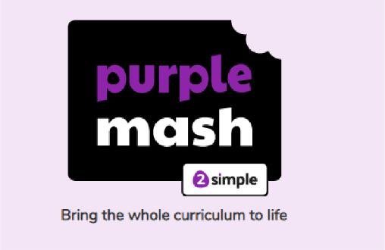

https://www.purplemash.com/sch/lakeside-dn4
Your child has been issued with a login for a resource called Purple Mash.
Sometimes, home learning will be set using this resource.
You can register on the parent portal to follow and support your child’s Purple Mash learning.

For parents who aren't familiar with Purple Mash or who want to register on the parent portal, please find an information guide here https://www.lakesidedoncaster.com/serve_file/914871
Children will receive feedback from teachers through Purple Mash for activities completed.

Lakeside Primary Academy Website (School Spider)

https://www.lakesidedoncaster.com/

Yourself and your child are able to log into the Lakeside Primary Academy Website.

This is our main virtual learning environment for children (VLE). From the website children will be able to access home-learning and upload completed work.

Children will receive feedback from teachers about completed learning on this platform .

TTS rock stars

TT Rock Stars
All our children in KS2 have access timestables rockstars, a programme that enables them to practice their times tables. Children can play at home on the website or on the apps, available for Amazon, Android and Apple devices. Younger children might need some help navigating to the website and entering the details but once they’re in, they just need some quiet space to get on with the games.

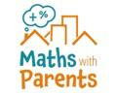

Maths with Parents

https://mathswithparents.com

Through an online platform, you and your child/ren will watch short videos explaining the topics your teacher chooses, and then play fun games and activities together using items around the home to explore the maths in the real world. Your maths teacher then gets your feedback and photos so they can see how you are getting on. Each child will access Maths with Parents via a code that is specific to their maths teacher – this may be different to their class teacher.

Gooseberry Planet
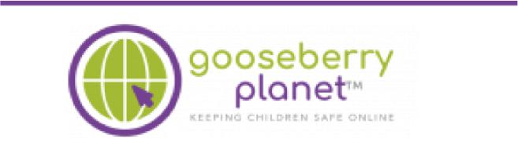
https://gooseberryplanet.com/
The Gooseberry Planet app is our school online safety programme.

Click on the link below to read the welcome letter to parents and find out how you can be part of your child's online safety learning journey.

Welcome-to-gooseberry-parent-.pdf
Your child's login details will be sent home with them for you to link with the Gooseberry Parent
App; and for them to access the resources on the Gooseberry Student App to support their learning in school. Please keep this safe. From the parent app you will be able to view parent information leaflets about the topic studied. Teachers will release games and activities through the programme when it is being taught.

Reading on your head

https://readingonyourhead.com/
Children in Y3-Y6 have been issued with a login for a resource called Reading on your head.
Reading quizzes will be set for children to show their understanding of texts we ask them to read.
The teacher will be able to see how your child’s scores from this activity.

Oak National Academy
https://www.thenational.academy/about-oak
This resource had hundreds of lessons for all primary ages. Lessons are delivered by a teacher through a pre-recorded video. The children then have quizzes, worksheets or creative activities for the children to practise the skills they have learnt.

WHAT IF MY CHILD HAS

SPECIAL NEEDS

Your child will be provided with remote learning too. This may be in the form of an individualised learning plan or support with the class learning plan. You will be contacted by your child’s teacher or our SENDCO during your child’s isolation to ensure that they are able to access the learning provided.

WHAT IF MY CHILD IS HAVING DIFFICULTY UNDERSTANDING THEIR LEARNING?

Contact school by telephone on 01302 368879 or email on admin@lakeside.doncaster.sch.uk or contact the class teacher directly.

WHAT IF I DO NOT HAVE

ACCESS TO THE INTERNET OR A

DEVICE TO WORK ON?

When you let school know your child will be absent, we will establish if you need help to access the internet, a device to work on or prefer a paper copy. Our Learning is a mix of on and offline work so children can learn without being online all day.

WHAT IF I CHOOSE TO GIVE MY CHILD EXTRA WORK?

Parents and Carers may choose to supplement the school’s online offer with support from online

companies and in some cases individual tutors. If you choose to do this, it is important to secure online support from a reputable organisation/individual who can provide evidence that they are safe and can be trusted to have access to children.

Remote Education Expectations

To reflect the importance of children continuing with education during periods of self-isolation or bubble closure, and current Government legal requirements, it is important that Remote Education is a partnership between home and school. Each year we share with you a Home School Agreement that outlines the role of school, parents and children in creating a positive school experience. In line with this, we feel that it is important to outline the role we all have in ensuring children have high-quality remote education.

Lakeside Primary Academy will:

- Establish the level of access a child will have to the remote learning offer and any support that may be needed such as access to a device, information on how to access the internet, physical resources needed to complete work, VLE login details and parent guidance on using tools such as video conferencing or the Pupil VLE
  - Plan remote learning activities that directly relate to the learning children would be experiencing in class including a balance of online and offline activities, learning from across the
curriculum, opportunities to practice key skills, and new learning introduced with a clear explanation

- Ensure that learning is accessible for all pupils from the first day of COVID-19 related absence and updated at regular intervals as appropriate

- Provide timely feedback on learning undertaken and support where needed. This will be by email , VLE comment or phone call as appropriate

- Keep in touch with parents and children who are not in school. This will primarily be through the VLE and email but text, video call and phone call may also be used. used.

Lakeside Primary Academy PARENTS will:

- Let school know by phone immediately if their child has to self-isolate and ensure that they, and their child, are contactable during normal school hours
- Access remote learning activities for their child on the first day of absence via the website or Pupil VLE
- Ensure their child completes a minimum 4 hours of remote learning each day combining both online and offline time (or contact the school to discuss issues with this)

- Seek immediate help from school staff if a child is having difficulty completing learning via phone call (01302 368879) or email (admin@lakeside.doncaster.sch.uk)
- Ensure that children return completed remote learning by the deadline given as instructed on the home learning plan

Lakeside Primary Academy CHILDREN will:

- Be contactable during normal school hours – but are not expected to always be in front of a device during this time
- Complete the remote learning activities that have been set by their teachers by the deadline given and share it with teachers as instructed

- Ask for help if they need it

- Let their parents and teachers know if they are not able to complete their work so they can be given support

- Remember that this is school work and so their teacher’s expectations for how it is completed and presented are the same as in school

- Remember that the VLE is managed by a member of school staff and the school code of conduct applies here too. Kind words are expected at all times.

