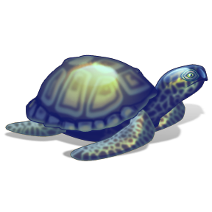

***The Turtle and the Beetle***

It was a sunny afternoon.

A little turtle swam in the pond.

It swam very slowly.

The turtle saw a black beetle.

The black beetle jumped away.

1. What was the weather like?

——————————————————————-

2. Is the turtle big or little?

——————————————————————-

3. Where was the turtle swimming?

——————————————————————

4. What did the beetle see?

——————————————————————

5. What did the beetle do?

——————————————————————