Lakeside Primary Academy VLE overview for week beginning 18/1/2021
Monday 18/1/2021
Spelling | Guided reading  9am Zoom | Maths  10am Zoom | English  11am Zoom | Topic | Other subjects
L.O: Introducing new spellings  Introduce the new word list using the Monday slide on the spelling sheets. Discuss meaning, on the spelling sheets split into syllables and sounds, work together word by word. | L.O: Pre read  This activity asks children to read this text we are focusing on this week then make notes on what they have read.  See the guided reading resources for the activity. | L.O: Divide fractions by integers  Pupils will learn how to divide fractions by integers (whole numbers).  Video link to introduce the lesson:  https://vimeo.com/  480707655 | L.O: Write a first draft of a recount (2days)  Writing the first draft trying to include all skills we have learnt to date but focussing on the two skills we are learning/revising for this learning journey. This will normally take two sessions. | PE –Target Throw  It’s time to work on your hand eye coordination! Roll up a pair of socks and try to throw them directly into a bucket, box or wash basket. After each successful throw take an estimated 30cm step backwards. Have 5 attempts and write your scores below followed by the total.  Challenge Yourself! Try to use a smaller target such as small bucket or bowl.  Following your target throwing activity can you answer the following questions:  In centimetres, how far away from the target did you get in 5 throws?  If you moved back 60cm instead of 30cm. How far away would you have finished from the target?  Can you convert both your answers into millimetres (mm)?
Mrs Deakin and Mrs McKenzie’s group

L.O: Multiply by 1 and 0

https://vimeo.com/475452114

Link to Mrs Mathers reading our class book – The Wolf Wilder https://LakesidePrimaryAcademy.screencasthost.com/watch/crV6FZPzb8
Today’s live lessons on Zoom
9am – reading  Zoom link:  Log into the website for Zoom links |  | 10am – maths  Zoom link:  Log into the website for Zoom links |  | 11am English  Zoom link:  Log into the website for Zoom links
Notes for the week:  You can also revise times tables on https://ttrockstars.com/  Additional activities are also provided on  https://mathswithparents.com/  Class: 6RC  Class Code: 300350  Class: 6NW  Class Code: 312591 |  | Notes for the week:  Try to read a book every day. You can find E-Books on www.oxfordowls.com  Complete the reading comprehension on https://readingonyourhead.com/ each week. |  | Notes for the week:

Lakeside Primary Academy VLE overview for week beginning 18/1/2021
Tuesday 19/1/2021
Spelling | Guided reading  9am Zoom | Maths  10am Zoom | English  11am Zoom | Topic | Other subjects
L.O: year 3/4 and Year 5/6 words  Introduce this week’s year three and four words using the Tuesday slide on the spelling sheets. Discuss meaning, use the spelling sheets to split into syllables and sounds, work together word by word. | L.O: Reading activity  This activity asks children to complete an activity based on the text we are reading this week.  See the guided reading resources for the activity. | L.O: Using BODMAS with fractions  Pupils will learn how to use BODMAS (which tells you what order to solve a calculation in) using fractions.  Video link to introduce the lesson:  https://vimeo.com/480708159 | L.O: Write a first draft of a recount (2days)  Continue writing your first draft of a recount. | L.O: Use and interpret maps  Pupils use and explore maps of the polar regions and complete questions using them.
Mrs Deakin and Mrs McKenzie’s group

L.O: Divide by 1 and itself

https://vimeo.com/478511830

Link to Mrs Mathers reading our class book – The Wolf Wilder https://LakesidePrimaryAcademy.screencasthost.com/watch/crV6FZPzb8
Today’s live lessons on Zoom
9am – reading  Zoom link:  Log into the website for Zoom links |  | 10am – maths  Zoom link:  Log into the website for Zoom links |  | 11am English  Zoom link:  Log into the website for Zoom links
Notes for the week:  L.O means learning objective. This is the skill we focus on each day.  You can also revise times tables on https://ttrockstars.com/  Additional activities are also provided on  https://mathswithparents.com/  Class: 6RC  Class Code: 300350  Class: 6NW  Class Code: 312591 |  | Notes for the week:  Try to read a book every day. You can find E-Books on www.oxfordowls.com  Complete the reading comprehension on https://readingonyourhead.com/ each week. |  | Notes for the week:

Lakeside Primary Academy VLE overview for week beginning 18/1/2021
Wednesday 20/1/2021
Spelling | Guided reading  9am Zoom | Maths  10am Zoom | English  11am Zoom | Topic | Other subjects
L.O: independent work  Using the Wednesday slide on the spelling sheets, practice the words independently. It is good to write them in sentences if you are comfortable with the spellings. | L.O: Vocabulary activity  This activity asks children to answer vocabulary questions based on the text we are studying this week.  See the guided reading resources for the activity. | L.O: Finding a fraction of an amount  Pupils will learn how to find a fraction of an amount  Video link to introduce the lesson:  https://vimeo.com/480708541 | L.O: Edit and improve first draft  Editing and improving - You are familiar with this as it is something we do in school for every learning journey. | L.O: Develop understanding of polar climates  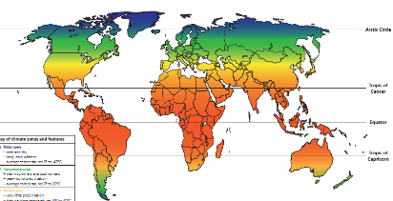  Pupils will explore and investigate the climate in the polar regions.
Mrs Deakin and Mrs McKenzie’s group

L.O: Multiply and divide by 6

https://vimeo.com/478522348

Link to Mrs Mathers reading our class book – The Wolf Wilder https://LakesidePrimaryAcademy.screencasthost.com/watch/crV6F4PzqN

Today’s live lessons on Zoom
9am – reading  Zoom link:  Log into the website for Zoom links |  | 10am – maths  Zoom link:  Log into the website for Zoom links |  | 11am English  Zoom link:  Log into the website for Zoom links
Notes for the week:  L.O means learning objective. This is the skill we focus on each day.  You can also revise times tables on https://ttrockstars.com/  Additional activities are also provided on  https://mathswithparents.com/  Class: 6RC  Class Code: 300350  Class: 6NW  Class Code: 312591 |  | Notes for the week:  Try to read a book every day. You can find E-Books on www.oxfordowls.com  Complete the reading comprehension on https://readingonyourhead.com/ each week. |  | Notes for the week:

Lakeside Primary Academy VLE overview for week beginning 18/1/2021
Thursday 21/1/2021
Spelling | Guided reading  9am Zoom | Maths  10am Zoom | English  11am Zoom | Topic | Other subjects
L.O: paired work  Today you will need a partner – a parent, sibling or pet if you are struggling. | L.O: Comprehension activity  This activity asks children to answer comprehension questions based on the text we are studying this week.  See the guided reading resources for the activity. | L.O: Fractions of an amount – finding the whole  Pupils will use finding a fraction of an amount to find the whole.  Video link to introduce the lesson:  https://vimeo.com/480708847 | L.O: Final draft of a recount (2 days)  Writing your final drafts to include your editing and improving. It is vital that you make continuous improvements as you go along. This means that you are further improving on your first draft as you write (beyond the editing and improving you have already done in your editing and improving session). This will normally take two sessions. | PE: Different rooms  Hop, skip, JUMP! Can you move around your house only using hopping, skipping and jumping as a method of travelling?  To start, hop to the first room and touch the furthest wall from the door.  Next, skip to the next room and touch the window  Finally, jump to the final room and touch all four walls.  Challenge Yourself! Move around the house only using the hop, skip and jump method  Once you have finished hopping, skipping and jumping around your house try to write a sentence below describing each room you entered. Try to use at least three adjectives in each sentence.
Mrs Deakin and Mrs McKenzie’s group

L.O: 6 times tables and division facts - No video link

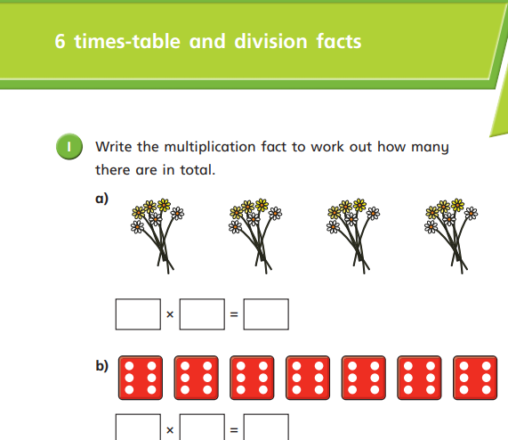

Today’s live lessons on Zoom
Link to Mrs Mathers reading our class book – The Wolf Wilder https://LakesidePrimaryAcademy.screencasthost.com/watch/crV6FMPzZm

9am – reading  Zoom link:  Log into the website for Zoom links |  | 10am – maths  Zoom link:  Log into the website for Zoom links |  | 11am English  Zoom link:  Log into the website for Zoom links
Notes for the week:  L.O means learning objective. This is the skill we focus on each day.  You can also revise times tables on https://ttrockstars.com/  Additional activities are also provided on  https://mathswithparents.com/  Class: 6RC  Class Code: 300350  Class: 6NW  Class Code: 312591 |  | Notes for the week:  Try to read a book every day. You can find E-Books on www.oxfordowls.com  Complete the reading comprehension on https://readingonyourhead.com/ each week. |  | Notes for the week:

Lakeside Primary Academy VLE overview for week beginning 18/1/2021
Friday 22/1/2021
Spelling | Guided reading  9am Zoom | Maths  10am Zoom | English  11am Zoom | Topic | Other subjects
L.O: spelling test  Ask an adult to test you on this week’s words. | L.O: Marking comprehension activity  This activity asks children to mark the questions they answered yesterday. It is best to do this session with an adult so you can discuss your answers and correct them.  See the guided reading resources for the activity. | L.O: Multiply fractions by integers  Pupils will learn how to multiply fractions by integers  Video link to introduce the lesson:  https://vimeo.com/475426110 | L.O: Final draft of a recount (2 days)  Continue and complete final draft of a recount. | E-safety session 2  t www.thinkuknow.co.uk/8_10/watch/  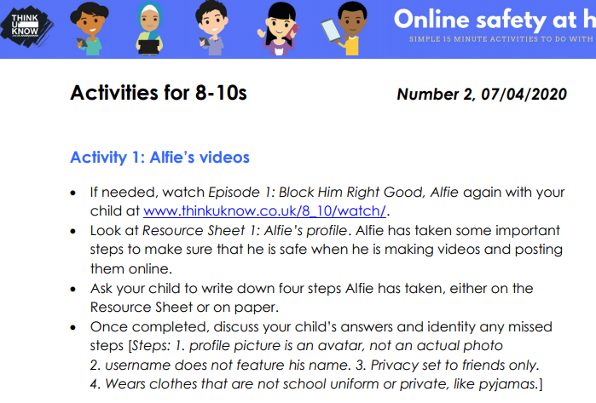
Mrs Deakin and Mrs McKenzie’s group

L.O: Multiply and divide by 9 - No video link
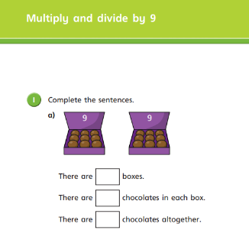

Today’s live lessons on Zoom
Link to Mrs Mathers reading our class book – The Wolf Wilder

9am – reading  Zoom link:  Log into the website for Zoom links |  | 10am – maths  Zoom link:  Log into the website for Zoom links |  | 11am English  Zoom link:  Log into the website for Zoom links
Notes for the week:  L.O means learning objective. This is the skill we focus on each day.  You can also revise times tables on https://ttrockstars.com/  Additional activities are also provided on  https://mathswithparents.com/  Class: 6RC  Class Code: 300350  Class: 6NW  Class Code: 312591 |  | Notes for the week:  Try to read a book every day. You can find E-Books on www.oxfordowls.com  Complete the reading comprehension on https://readingonyourhead.com/ each week. |  | Notes for the week:

