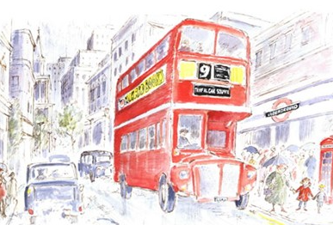
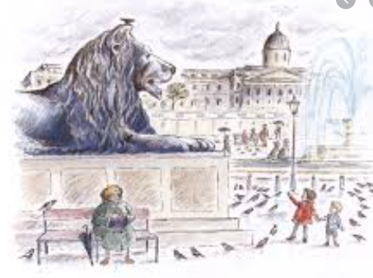
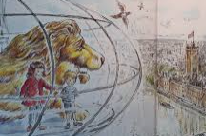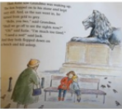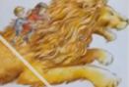

Tuesday 12th January 2021
LO: To sequence the story of ‘Katie in London’.
 | Me | Teacher
Sequence the picytures in the correct order.
Use time words to sequence in the correct order.
Write one or two sentences to go with some pictures.
Write a simple sentence to go with each picture.
Use the correct punctuation.
EXT- Extend using and

Challenge – Can you write a sentence to go with each picture. If you need to listen to the story again you can use the link on You tube.

