Lakeside Primary Academy VLE overview for week beginning 11/1/2021
Monday 11/1/2021
Spelling | Guided reading  9am Zoom | Maths  10am Zoom | English  11am Zoom | Topic | Other subjects
L.O: Introducing new spellings  Introduce the new word list using the Monday slide on the spelling sheets. Discuss meaning, on the spelling sheets split into syllables and sounds, work together word by word. | L.O: Pre read  This activity asks children to read this text we are focusing on this week then make notes on what they have read.  See the guided reading resources for the activity. | L.O: Introduction to BODMAS  Pupils develop their understanding of BODMAS (Brackets, Operations, Division, Multiplication, Addition and Subtraction) which tells pupils what order to do calculations in.  Video link to introduce the lesson:  https://vimeo.com/465421787 | L.O: Understanding a genre of writing  Introduction to genre we are writing. Looking at a model text and highlighting the writing tools and vocabulary used.  https://www.literacyshed.com/ aviatrice.html. | 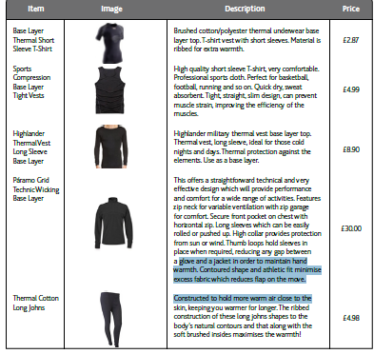  Planning an arctic expedition – Use these resources to complete the lesson | PE – ABC Hunt  Travel around your house in a variety of ways and try to find an item for each letter of the alphabet. You only have 15 Minutes to try to complete the alphabet. Examples: A = Apple B = Book C = Chair and so on..  Using only the letters you have managed to fill in above, how many words can you create?
Link to Mrs Mathers reading our class book – The Wolf Wilder https://LakesidePrimaryAcademy.screencasthost.com/watch/crVhFHP2G7
Today’s live lessons on Zoom
9am – reading  Zoom link:  See daily homework on the VLE for Zoom links |  | 10am – maths  Zoom link:  See daily homework on the VLE for Zoom links |  | 11am English  Zoom link:  See daily homework on the VLE for Zoom links
Notes for the week:  You can also revise times tables on https://ttrockstars.com/  Additional activities are also provided on  https://mathswithparents.com/  Class: 6RC  Class Code: 300350  Class: 6NW  Class Code: 312591 |  | Notes for the week:  Try to read a book every day. You can find E-Books on www.oxfordowls.com  Complete the reading comprehension on https://readingonyourhead.com/ each week. |  | Notes for the week:

Lakeside Primary Academy VLE overview for week beginning 11/1/2021
Tuesday 12/1/2021
Spelling | Guided reading  9am Zoom | Maths  10am Zoom | English  11am Zoom | Topic | Other subjects
L.O: year 3/4 and Year 5/6 words  Introduce this week’s year three and four words using the Tuesday slide on the spelling sheets. Discuss meaning, use the spelling sheets to split into syllables and sounds, work together word by word. | L.O: Reading activity  This activity asks children to complete an activity based on the text we are reading this week.  See the guided reading resources for the activity. | L.O: BODMAS investigation  Pupils use their knowledge of BODMAS to conduct an investigation.  Video link to introduce the lesson:  https://vimeo.com/465421787 | L.O: Understand the vocabulary used in a recount text  Looking in depth at the first skill we are learning/revising and completing a task based on this. |  | Art – Create an emotion wheel  https://do2learn.com/organizationtools/  EmotionsColorWheel/
Link to Mrs Mathers reading our class book – The Wolf Wilder https://LakesidePrimaryAcademy.screencasthost.com/watch/crVhqnP2sj
Today’s live lessons on Zoom
9am – reading  Zoom link:  See daily homework on the VLE for Zoom links |  | 10am – maths  Zoom link:  See daily homework on the VLE for Zoom links |  | 11am English  Zoom link:  See daily homework on the VLE for Zoom links
Notes for the week:  L.O means learning objective. This is the skill we focus on each day.  You can also revise times tables on https://ttrockstars.com/  Additional activities are also provided on  https://mathswithparents.com/  Class: 6RC  Class Code: 300350  Class: 6NW  Class Code: 312591 |  | Notes for the week:  Try to read a book every day. You can find E-Books on www.oxfordowls.com  Complete the reading comprehension on https://readingonyourhead.com/ each week. |  | Notes for the week:

Lakeside Primary Academy VLE overview for week beginning 11/1/2021
Wednesday 13/1/2021
Spelling | Guided reading  9am Zoom | Maths  10am Zoom | English  11am Zoom | Topic | Other subjects
L.O: independent work  Using the Wednesday slide on the spelling sheets, practice the words independently. It is good to write them in sentences if you are comfortable with the spellings. | L.O: Vocabulary activity  This activity asks children to answer vocabulary questions based on the text we are studying this week.  See the guided reading resources for the activity. | L.O: Introduction to long division  Pupils develop their understanding of how to add and subtract fractions and ensure they understand this key mathematical skill.  Video link to introduce the lesson:  https://vimeo.com/461800078 | L.O: Using apostrophes for possession and plurals accurately.  Looking in depth at the first skill we are learning/revising and completing a task based on this. | Exploring the Arctic and Antarctic  This half term our topic is ‘Frozen Kingdom’ where pupils develop their understanding of the Arctic and Antarctic.  Today we would like you to do your own research about the Arctic and Antarctic – create an information poster with any important information you find.  The following websites are great for further research and extending your learning:  National Geographic kids:  https://kids.nationalgeographic.com/explore/nature/habitats/polar/  Coolkidfacts:  https://www.coolkidfacts.com/polar-climate-facts/  The School Run:  https://www.theschoolrun.com/homework-help/polar-habitats
Link to Mrs Mathers reading our class book – The Wolf Wilder

Today’s live lessons on Zoom
9am – reading  Zoom link:  See daily homework on the VLE for Zoom links |  | 10am – maths  Zoom link:  See daily homework on the VLE for Zoom links |  | 11am English  Zoom link:  See daily homework on the VLE for Zoom links
Notes for the week:  L.O means learning objective. This is the skill we focus on each day.  You can also revise times tables on https://ttrockstars.com/  Additional activities are also provided on  https://mathswithparents.com/  Class: 6RC  Class Code: 300350  Class: 6NW  Class Code: 312591 |  | Notes for the week:  Try to read a book every day. You can find E-Books on www.oxfordowls.com  Complete the reading comprehension on https://readingonyourhead.com/ each week. |  | Notes for the week:

Lakeside Primary Academy VLE overview for week beginning 11/1/2021
Thursday 14/1/2021
Spelling | Guided reading  9am Zoom | Maths  10am Zoom | English  11am Zoom | Topic | Other subjects
L.O: paired work  Today you will need a partner – a parent, sibling or pet if you are struggling. | L.O: Comprehension activity  This activity asks children to answer comprehension questions based on the text we are studying this week.  See the guided reading resources for the activity. | L.O: Using long division  This activity allows children to practise their skills in long division through a range of question types.  Video link to introduce the lesson:  https://vimeo.com/463003643 | L.O: Use relative clauses  Use relative clauses beginning who, which and that to add detail and description  Looking in depth at the second skill we are learning/revising and completing a task based on this. | PE: Jump Against the Clock  How many star jumps can you do in a set amount of time? Time yourself or get another member of your house hold to help.  15 seconds  30 seconds:  60 seconds:  Challenge Yourself! We have doubled the time on each go. Can you double your score?  Using your scores from above, can you answer the following maths related questions?  What is the total amount of star jumps completed?  Find the difference between your highest and lowest score?  If you did this activity three times in a week, what would be your total score for the week?
Today’s live lessons on Zoom
Link to Mrs Mathers reading our class book – The Wolf Wilder

9am – reading  Zoom link:  See daily homework on the VLE for Zoom links |  | 10am – maths  Zoom link:  See daily homework on the VLE for Zoom links |  | 11am English  Zoom link:  See daily homework on the VLE for Zoom links
Notes for the week:  L.O means learning objective. This is the skill we focus on each day.  You can also revise times tables on https://ttrockstars.com/  Additional activities are also provided on  https://mathswithparents.com/  Class: 6RC  Class Code: 300350  Class: 6NW  Class Code: 312591 |  | Notes for the week:  Try to read a book every day. You can find E-Books on www.oxfordowls.com  Complete the reading comprehension on https://readingonyourhead.com/ each week. |  | Notes for the week:

Lakeside Primary Academy VLE overview for week beginning 11/1/2021
Friday 15/1/2021
Spelling | Guided reading  9am Zoom | Maths  10am Zoom | English  11am Zoom | Topic | Other subjects
L.O: spelling test  Ask an adult to test you on this week’s words. | L.O: Marking comprehension activity  This activity asks children to mark the questions they answered yesterday. It is best to do this session with an adult so you can discuss your answers and correct them.  See the guided reading resources for the activity. | L.O: Using long division – further practise  This activity allows children to practise their skills in long division through a range of question types  Video link to introduce the lesson:  https://vimeo.com/463003911 | L.O: Planning our first draft using a planning template.  Planning your recount of the day you flew a jet plane from the point of view of Jacqueline Auriol. |  | E-safety – session one.  https://www.thinkuknow.co.uk  /8_10/watch/  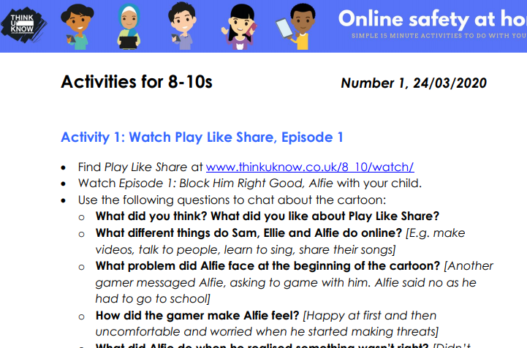
Today’s live lessons on Zoom
Link to Mrs Mathers reading our class book – The Wolf Wilder

9am – reading  Zoom link:  See daily homework on the VLE for Zoom links |  | 10am – maths  Zoom link:  See daily homework on the VLE for Zoom links |  | 11am English  Zoom link:  See daily homework on the VLE for Zoom links
Notes for the week:  L.O means learning objective. This is the skill we focus on each day.  You can also revise times tables on https://ttrockstars.com/  Additional activities are also provided on  https://mathswithparents.com/  Class: 6RC  Class Code: 300350  Class: 6NW  Class Code: 312591 |  | Notes for the week:  Try to read a book every day. You can find E-Books on www.oxfordowls.com  Complete the reading comprehension on https://readingonyourhead.com/ each week. |  | Notes for the week:

