23rd November 2020

Dear Parents and Carers

As you might have guessed Christmastime activities will look very different in school this year. Due to the restrictions in place we are unable to mix bubbles or have more than one class in the hall. This means we can’t hold concerts or assemblies and activities will be limited to each classroom base. However, we have come up with some alternatives which are outlined below:

Christmas cards
Children can bring cards but only for pupils in their own class. These will be placed in a container to quarantine and distributed the following week. We are unable to share cards outside of class bubbles. We fully understand if you decide to give Christmas cards a miss this year.

Christmas parties
Christmas ‘parties’ will be each class having a day of Christmas activities and games and some food provided by school at a small cost. These will take place in the last week of term and teachers will notify you of the exact day for their class nearer the time.
Christmas dinner
The children will still be having their Christmas dinner in their class bubble. This will be on Friday 11th December.
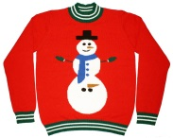
Christmas Jumper Day (for charity)
This will be on Friday 11th December, the same day as Christmas dinner.

Christmas Panto
Children will be able to watch Cinderella Live during the last week of term. This is a livestream entertainment purchased by school as we would normally have a visiting theatre group.

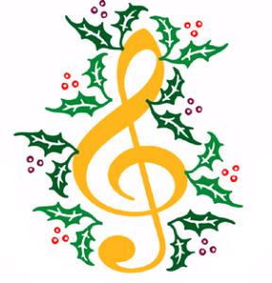
Christmas performances
Unfortunately because of restrictions we will not be able to have a Christmas concert with several classes together in the school hall. However, the children and staff are preparing a song or poem which will be videoed and put together to create a ‘whole school’ concert.

This will be made available on the school website and social media at the end of term. A separate consent letter has been issued by each teacher for this event. If you do not wish your child to take part or would like your child to join in during rehearsals but not appear on the video you must tick the correct boxes on the letter. Please confirm by phone or with the teacher directly if this is the case.

Christmas gifts
We know that some of you are very generous with your gifts to your child’s class teacher at this time of year, as always there is absolutely no expectation that these are given to the teachers. However, if you would like to do this we will place a box outside the main entrance on Monday 14th December. Please place any gifts in here, clearly marked with the staff’s name, we can then quarantine them for three days before giving them to the staff.

We will be giving the children a small gift from the academy as usual, please be assured that these will be wiped and clean before handing them to your child.

As always, the above plans are subject to change should government guidelines change. We will keep you updated if there are any changes.

If you would like to discuss any of the arrangements or have any questions please contact the school office to speak to Mr Bullock, Mrs McCrae or Mrs Stringer.

Thank you for your ongoing support at this challenging time.

Training Day
Please note that the first day back after the holiday – Monday 4th January - is a staff training day. School re-opens on Tuesday 5th January 2021.

Yours sincerely
Mr J Bullock
Head Teacher

