Week 5  1/2 RB and 1JD | Reading | Writing | Maths | Topic
Monday | Read your reading book or choose one on Oxford Owl. | Handwriting – i, j, l  Practise these letters carefully, why not make it interesting and practise in flour or rice or even with some paint. | LO: To order ordinal numbers correctly.  Line 10 objects up and say their positon, for example: 1st, 2nd, 3rd…  Then ask the questions point to the 4th object. See sheet to go with this task. | DT  Create your own Moon Buggy or Spaceship – draw a picture of it first so that you have created a design so that it makes it easier to make.  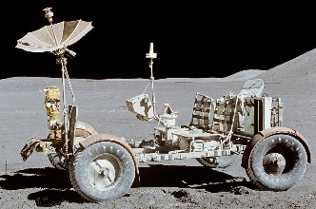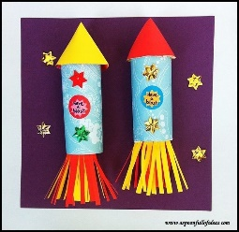
Tuesday | Practise reading the red and green words. | Handwriting – q, p, g  Practise these letters carefully, why not make it interesting and practise in flour or rice or even with some paint. | LO: To use tens and ones.  Show tens and ones  l . . . . 14  l . . . . . . . . 18  Can you write the answers? | PE –  Joe Wicks workout – You tube link:  https://youtu.be/fAUckPMJKSY  https://youtu.be/uqLNxJe4L2I  https://youtu.be/SbFqQarDM50
Wednesday | Choose 3 green words and put them into a sentence.  Remember to use a capital letter to start and a full stop to finish. | English  LO: To write a story.  Write the beginning of the story Astro Girl – retell the story as you go. Make sure that you are using capital letters, full stops and finger spaces throughout. | LO: To use tens and ones.  Draw your own tens and ones pick a number between 10 and 20.  Could you draw with tens and ones the number 23?  Think about how many tens and how many ones. | PHSE  To talk about what we are grateful for.  I am grateful for the time I get to spend with my family.  I am grateful for all the things my family do to help me stay safe.
Thursday | Read your reading book or choose one on Oxford Owl. | English  LO: To write a story.  Write the middle and end of the story Astro Girl – retell the story as you go. Make sure that you are using capital letters, full stops and finger spaces throughout. | Number bonds to 20  If we know our number bonds to 10 how could we use these to find them to 20?  0+20=20  1+19=20  2+18=20 | Topic DT-  Look at your design of your model then make this model using things around the house.  Challenge:  Can you make it wheel forwards and backwards?  See what things you can use for wheels, bottle tops, candle shells, thick cardboard.
Friday | If you want to have a test on some of the green words or speedy green words get an adult to test you on them. See how speedy you can be. | Common Exception words  Practise reading and spelling these common exception words. | Practise your 2 and 10 times tables,  From…  0x2=0 all the way to 12x2=24  0x10=0 all the way to 12x10=120

