WC 12/10/20 FS1
This week the FS1 children will be singing the nursery rhyme ‘5 Little Ducks Went Swimming One Day’.
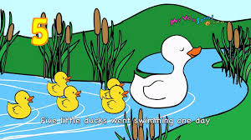
We will be counting out the ducks and talking amount how many are left as they swim away…..

This week we have also been busy…….
Singing- ‘Row,Row Row Your Boat’
And choosing our favourite rhymes to sing.
The children have also enjoyed talking about he weather and the changing season. They have counted out conkers and looked at some Autumn leaves.
Could you go out and find some conkers, acrons and leaves. Can you talk about what clothes you to wear to keep warm and what your favourite weather is1
We hope you like the ideas we have suggested to support your child as they learn at home
Mrs Callan

