Week Commencing: 5.10.20 This week we are learning the following…
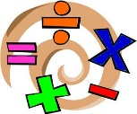  Maths | English | Topic – Potions
Negative Numbers  https://vimeo.com/460234751  These links take you to a video to explain the learning in maths this week. There is a maths activity on the VLE for homework this week.  You can also revise timestables on https://ttrockstars.com/  Additional activities are also provided on  https://mathswithparents.com/  your class code is: 747212 | This week we are exploring prepositions and using them in our writing. We shall be looking at pictures of fantasy settings and writing descriptions of what we imagine Dream Country might look like in the BFG. We shall be concluding our work on the BFG by writing another character description of a giant – one of the BFG’s cousins! The EKPG – the enormous kind polite giant or perhaps  THE VLHG – the very large happy giant! You decide.  Reading  Our class text is the BFG.  These are some of the questions we use during reading lessons in school. https://www.literacyshedblog.com/uploads/1/2/5/7/12572836/ks2_reading_vipers.pdf  You could complete the reading comprehension on https://readingonyourhead.com/ | History of medicine.  This week we will be looking at the following image and using it to find evidence of what medicine and anaesthetic was like in the past.  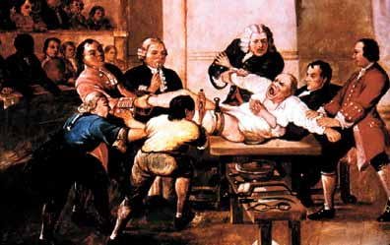  We will then write a comparison to surgery in the past compared to today.  Have a look at the topic overview for other ideas linked to this terms topic.

