Hi everyone,
I hope you are all well and staying safe.
I have put together some ideas and information so you can have ago at, develop and practise your artistic skills at home. Don’t forget to post anything you create on the website, I would love to see what you have made, created or attempted whilst you have been at home. Most importantly have fun as you develop your artistic skills.

DARTS Is our own local resource that wants ‘to create art with people in Doncaster to improve life, learning and health.’

https://wearedarts.org.uk/
https://wearedarts.org.uk/intro-to-collage/
https://wearedarts.org.uk/visual-arts-at-home/
Please have a look at their site, it has some great ideas and activities that you can access at home.

KS1 and KS2
If you enjoy art then the websites, films and ideas below are for you. Take a look, what can you create at home!
https://www.twinkl.co.uk/resources/keystage2-ks2/ks2-subjects/ks2-art
https://www.paulcarneyarts.com/online-drawing-home
Would you like to go on an art adventure?
Learn about different artists?
See more art videos? Draw, paint or make something?

Tate Kids has lots of different activities on their website:

https://www.tate.org.uk/kids

All about Sketchbooks
Do you miss your school sketchbook? No problem, you can now make your own at home.

AccessArt has created a short online course suitable for all ages and all abilities to use at home. No special materials are required, and it is completely free to take part.

For more information, please follow the link below:
https://www.accessart.org.uk/sketchbooks-an-online-course-for-children-families-parents-teachers/

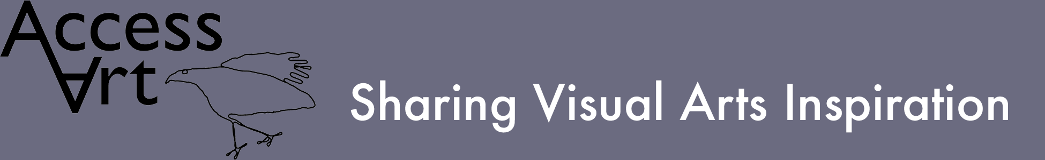

https://www.accessart.org.uk/

This site is full of ideas, examples and activities that you can do at home. Please find an example below of a short film clip that models ‘Drawing Large’, why don’t you have a go.

https://vimeo.com/423967574
Here are some other links from the AccessArt website.
https://www.accessart.org.uk/developing-drawing-skills-primary-school/
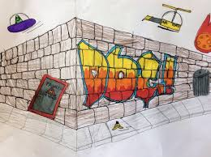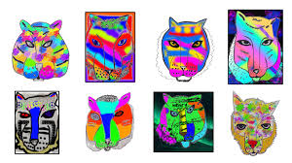
What would you draw or create? Something with perspective! Something colourful and bright!

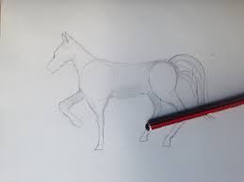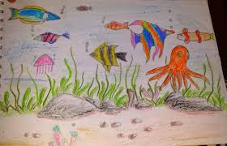
Your favourite animal! Or a scene with lots of different elements in the picture!

Can you research your favourite artist or discover a new artist you did not know about? Can you compare and contrast the art work that you discover? Why do you like some pictures and not others? Do you like the focus of the art work? I like art work that has a natural theme, because I love wild life and nature.
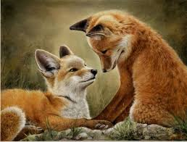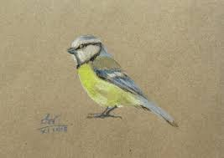
What are you interested in? Can you find some art work that relates to your interests?

Here are some artists you could find out about.

David Hockney
William Morris
Giuseppe Arcimboldo
Claude Monet
Frida Kahlo

What language and vocabulary would you use to describe yours and others art work? Can you describe the similarities and differences between two pieces of work?
Could you use of the vocabulary and language suggestions below? Put your thinking caps on and have a go!
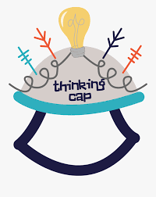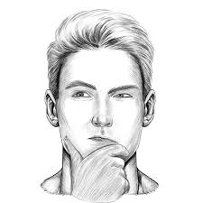

delicate | subtle | smooth | small
simple | contrasting | uneven | vibrant
bold | dramatic | swirling | colourful
thick | rough | flowing | bright
thin | fine | big | realistic

Galleries and Museum
Please find listed below some great museum and gallery links – you don’t even need to go out to look at some fantastic and inspiring art, created by many different artists.
http://www.artsandculture.google.com/partner/van-gogh-museum?hl=en
http://www.metmuseum.org/art/online-features/metkids/
https://www.louvre.fr/en/visites-en-ligne/
http://www.artsandculture.google.com/partner/national-gallery-of-art-washington-dc?hl=en
I hope you enjoy and have fun creating, trying out, visiting the websites and developing your skills.
Take care and stay safe!
Mrs Callan (Art Lead)

