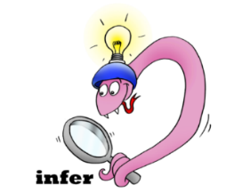
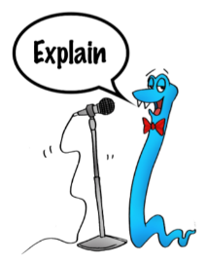
Date:___________________
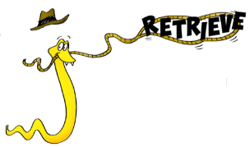
Comprehension Questions – Chapter 14
The fiendishly clever plan

1.Toothless will not help Hiccup or the other dragons. What is your opinion of his behaviour?

___________________________________________________________________________________

___________________________________________________________________________________
2 marks

2. Snotlout seems to have met his match in Thuggery from the Meatheads. What does the phrase met his match mean?

____________________________________________________________________________________
1 mark

3. Explain the thinking behind Hiccup’s fiendishly clever plan of using feather bombs – what is he hoping they will do to the Sea Dragon and why?

____________________________________________________________________________________

____________________________________________________________________________________

____________________________________________________________________________________

____________________________________________________________________________________
3 marks

4. Fireworm shows true courage and bravery in this chapter.
Give two examples from the chapter where this is demonstrated.

___________________________________________________________________________________

___________________________________________________________________________________
2 marks

5.'Cold steel is the only language a creature like that can understand’ p.181 explains Snotlout. What does this mean?
___________________________________________________________________________________
________________________________________________________________________________________
2 marks

6. Why do you think Snotlout is not keen to help with the plan? p181
________________________________________________________________________________________
________________________________________________________________________________________
2 marks

7. Why is it important that the boys from both tribes and the dragons work together as a team?

___________________________________________________________________________________

___________________________________________________________________________________
2 marks

