Date:_____________________ 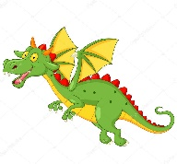

Independent task

Hiccup has a great idea to defeat the Sea Dragons, but if his plan had failed, what else could he have done? Remember, their skin is so tough that weapons are useless and, of course, they are stupendously enormous! You have to be creative and inventive!

My fiendishly clever plan to defeat a Sea Dragon Maximus

