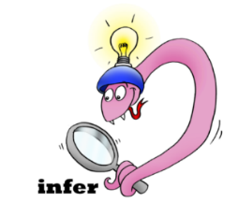
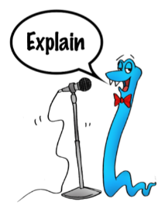
Date:___________________
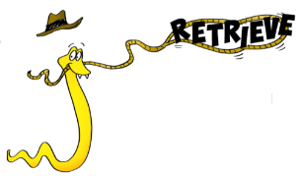
Comprehension Questions – Chapter 18

1.Why does Toothless not hear the arrival of Stoick and the other warriors?

___________________________________________________________________________________

___________________________________________________________________________________
2 marks

2. Why have all the dragons flown away to safety and abandoned their masters?

____________________________________________________________________________________
1 mark

3. What reasons are given in the text to explain why Toothless decides to help Hiccup? Do you agree with the reasons given?

____________________________________________________________________________________

____________________________________________________________________________________

____________________________________________________________________________________

3 marks

4. Explain what Toothless does to try and help Hiccup.

___________________________________________________________________________________

___________________________________________________________________________________
2 marks

5. P209 Find and copy the phrase which shows that Stoick was very concerned about Hiccup and wanted to see if he was okay
________________________________________________________________________________________
________________________________________________________________________________________
1 mark

6. Why does the Green Death explode? What had Hiccup done?

___________________________________________________________________________________

___________________________________________________________________________________
2 marks

7. How is Hiccup nearly killed again as the dragon explodes?

____________________________________________________________________________________

____________________________________________________________________________________

2 marks

8. How does Stoick manage to save his son’s life?

____________________________________________________________________________________

____________________________________________________________________________________
1 mark

9. What kind of relationship do you think Hiccup and Toothless will have now that Toothless has saved Hiccup’s life?

____________________________________________________________________________________

____________________________________________________________________________________

____________________________________________________________________________________

10. Do you think the other dragons will return to their masters?

___________________________________________________________________________________

___________________________________________________________________________________

