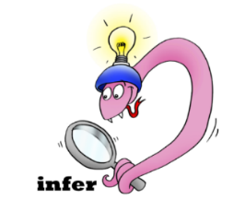
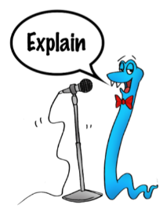
Date:___________________
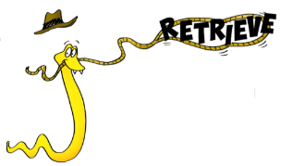
Comprehension Questions – Chapter 16 and
17

Chapter 16

1.What phrases on p196 lets the reader know that the Green Death is badly injured? There are three you could use.

___________________________________________________________________________________

___________________________________________________________________________________
2 marks

2. How does the Green Death make the boys come out of the bracken?

____________________________________________________________________________________
1 mark

3. Think of three other words that mean the same as cavernous.

____________________________________________________________________________________

____________________________________________________________________________________

3 marks

Chapter17

4. Why does Hiccup snatch his foot away from the dragon’s throat?

___________________________________________________________________________________

___________________________________________________________________________________
2 marks

5. Is it true that the Green Death had intended to swallow Hiccup whole?
________________________________________________________________________________________
________________________________________________________________________________________
1 mark

6. What is the important discovery that Hiccup makes?

___________________________________________________________________________________

___________________________________________________________________________________
2 marks

7. Find three things that make Hiccup confused as he hangs in the dragon’s mouth.

____________________________________________________________________________________

____________________________________________________________________________________

2 marks

8. The Roman spear is described as being stout (p203)
What do you think this word might mean?

____________________________________________________________________________________

____________________________________________________________________________________
1 mark

9. It appears that the spear is going to break – what do you predict will happen to Hiccup in chapter 18 which we will be reading tomorrow? Bit of a clue – chapter 18 is called The extraordinary bravery of Toothless – so think how the dragon might help Hiccup in his hour of need!

____________________________________________________________________________________

____________________________________________________________________________________

____________________________________________________________________________________

