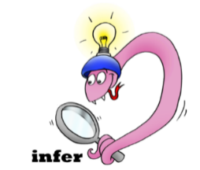
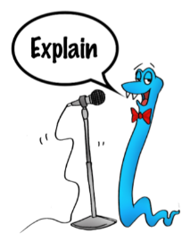
Date:___________________
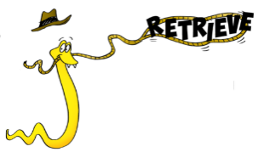
Comprehension Questions – How to train your Dragon – chapter 12

1. Why does Hiccup prefer to go alone to face the dragon? Find and copy the phrase to evidence your answer.

______________________________________________________________________

______________________________________________________________________
2 marks

2. Find and copy the phrase that tells us that Hiccup is scared ?
_____________________________________________________________________

1 mark

3. How is this dragon different to the other? Why do you think this?
_____________________________________________________________________

_____________________________________________________________________
2 marks

4. Why does the dragon refer to Hiccup as supper?

______________________________________________________________________

______________________________________________________________________
2 marks

5. why does the dragon say “the supper has shown intelligence?

______________________________________________________________________
1 mark

6. Infer. Why do you think that the dragon trembles when Hiccup tells him his full name?

______________________________________________________________________

______________________________________________________________________

______________________________________________________________________

3 marks

7. Why does the dragon tell Hiccup to come back in a few hours?

______________________________________________________________________

______________________________________________________________________
2 marks

8. What do you think the peoples reaction will be after Hiccup told them the dragon was going to kill them?

______________________________________________________________________

______________________________________________________________________
2 marks

