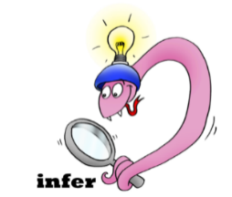
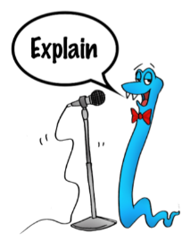
Date:___________________
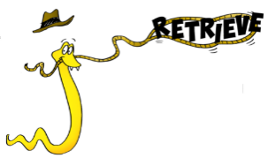
Comprehension Questions – How to train your Dragon – chapter 11

1. Why is Thor so angry?

______________________________________________________________________

______________________________________________________________________
2 marks

2. Find and copy 2 expanded noun phrases that imply Thor is angry?
_____________________________________________________________________

_____________________________________________________________________
2 marks

3. Why was Stoick worrying?

______________________________________________________________________

______________________________________________________________________
2 marks

4. What kind of father and leader do you think Stoick is? Provide proof for your answer.

______________________________________________________________________
1 mark

5. can you sort the following words into the correct table
Hiccup’s village Its victim’s screams
The Chiefs house
The Vikings’ heads

Apostrophe for single possession | Apostrophe for plural possession

3 marks

6. What is Mogadon outraged about?

______________________________________________________________________

______________________________________________________________________
2 marks

7. why are the people unimpressed by the fact that there was a dragon on the beach?

______________________________________________________________________

______________________________________________________________________
2 marks

8.Find and copy 3 adjectives used to describe the dragon?
______________________________________________________________________

______________________________________________________________________

______________________________________________________________________
3 marks

