1JD  1/2RB | Reading | Writing | Maths | Topic
Monday | Read your reading book or choose one on Oxford Owl. You could also listen to a storyline online – use the link  https://www.storylineonline.net/ | Handwriting:  Practise capital letters.  K  L  M  N  Think of some names that begin with those letters. | LO: To compare objects within 50.  Show the children the apples on the board – how do we know how many we have? What could we do? What would make it easy? The children should have prior knowledge of making 10 to make it easier to count on.  Show 2 tens frames – how could we use these?  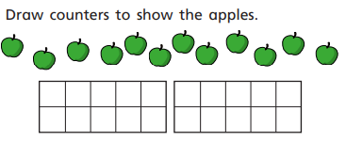  Show a different amount – faces how many do we have how do we know? Then look at comparing the two sets of objects.  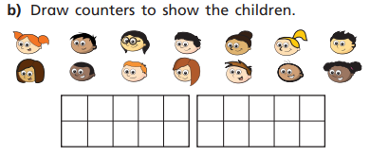  There are _________ apples.  There are _________ faces.  There are _____ faces than apples.  There are fewer ___________ than ____________. | PHSE:  Think about your friends, draw a picture of your friends who you play with at school.
Tuesday | Read your reading book or choose one on Oxford Owl. | English:  Write the story of Little Red Riding Hood as part of the warning tale – hook lesson for our new story the Selfish Giant. | LO: Order numbers to 50 using place value knowledge.  Show 3 different numbers - one drawn in base 10, one with tens frame and one in counters.  What do we have to do first? How do we know which is the biggest? Smallest and how could we use this place value knowledge to order the numbers?  34, 23 and 14. | PE  You tube- Joe Wicks.
Wednesday | Read your reading book or choose one on Oxford Owl. | English  Make a picture of the Selfish Giant – what do you think that he might look like? Remember to give him a name and make sure that you use some describing words to tell someone else what he is like. | LO: Order numbers to 50.  Show 3 numbers and ask the children to order these numbers, once they have ordered them ask how they know that this is right. How can we check?  Repeat with another 3 numbers and assess the children’s learning. | School Days:  Write a paragraph as if you were a child in a Victorian Classroom. Think about what they did and what they had to do to learn each day. Make sure you use capital letters and full stops correctly throughout.
Thursday | Practise reading the red and green words.  See how speedy you can get. | Handwriting:  Practise capital letters  O  P  Q  R  Think of some names that begin with those letters. | LO: To compare numbers within 50.  Compare numbers draw, 34 in tens and ones and then draw 22 and compare the two. Talk about the place value and tens and ones. Use the mathematical language.  Complete some more and add in the equality signs <>=.  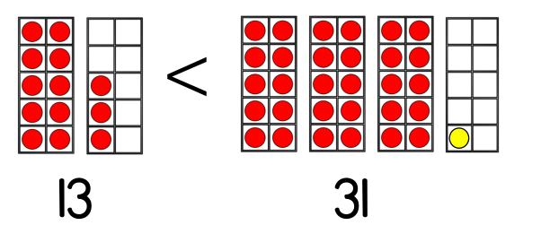  Look at this and see whether they think that it is true or false. | School Days:  Write what they used before in school in the Victorian classroom and write about what they use now. Think about artefacts.
Friday | Choose 3 green words and put them into a sentence. | English:  Make a role play scene of a garden and think about the selfish giant. | Maths with Parents:  Try the task that has been picked online and upload your work. | RE:  Shabbat – Talk about some of the things that you do with your family to enjoy family time. You could write some things down.

