1JD  1/2RB | Reading | Writing | Maths | Topic
Monday | Read your reading book or choose one on Oxford Owl. You could also listen to a storyline online – use the link  https://www.storylineonline.net/ | Handwriting:  Practise capital letters.  A  B  C  D  E  Think of some names that begin with those letters. | LO: To count to 50 by making tens.  Share LO and SC with children, what do we know about making tens.  How can we make tens? Use tens frame, base 10 tens and ones.  Share but without the numbers.  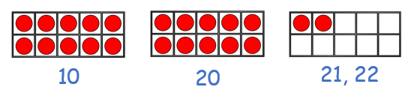  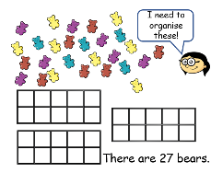  How can we count to the number without counting each one?  Model with the children.  What else could we do?  Model with tens and ones and then a random number of circles where they need to circle ten and write 10 under then another 10 and do the same – count on when they get to the end. | PHSE:  Think about your family, draw a picture of all the people who live in your house.
Tuesday | Read your reading book or choose one on Oxford Owl. | English:  Write the story of Little Red Riding Hood as part of the warning tale – hook lesson for our new story the Selfish Giant. | LO: To represent numbers to 50.  Share LO and SC with children, what do we call the number on the left (tens) on the right (ones).  Show children some numbers and ask them to say what number it is 33, 27, 44, 49 e.t.c.  How do we represent these numbers?  Draw the part, part whole model.  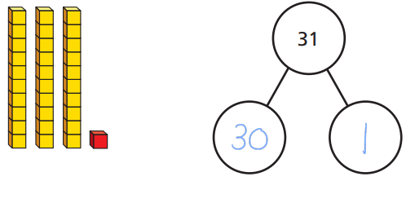Not 3 and 1 – 30 and 1 – 3 tens represents 30 and 1 represent the ones.  Repeat with different numbers – 45, 23 and 50. Showing in different ways. | PE  You tube- Cosmic Yoga for Kids.
Wednesday | Read your reading book or choose one on Oxford Owl. | English  Make a picture of the Selfish Giant – what do you think that he might look like? Remember to give him a name and make sure that you use some describing words to tell someone else what he is like. | LO: Find one more than a given number to 50.  Children to be shown a range of numbers on the board – using the counting on strategy can you find one more than the given number?  41 ___ 33 ____  49 ___ 27 ____  Use either the hundred square of draw a number line starting with the number given to show one more jump and what number do we land on? | School Days:  Identify whether the statements are true or untrue then order them in the table.
Thursday | Practise reading the red and green words.  See how speedy you can get. | Handwriting:  Practise capital letters  F  G  H  I  J  Think of some names that begin with those letters. | LO: Find one less than a given number below 50.  Children to be shown a range of numbers on the board – using the counting on strategy can you find one less than the given number?  ___ 41 ____ 33  ___ 49 ____ 27  Use either the hundred square of draw a number line starting with the number given to show one less jump and what number do we land on? | Arts and Crafts:  Draw a picture of what it would have been like in the Victorian Classroom – Take a look on google for some ideas.
Friday | Choose 3 green words and put them into a sentence. | English: | Maths:  Practise your 2, 5 and 10 x tables up to  12 x 2 =  12 x 5 =  12 x 10 = | RE:  Shabbat – What do we do on different days of the week – what is special to us on each day.

