Week 1 Home Learning:
Simple Subtraction
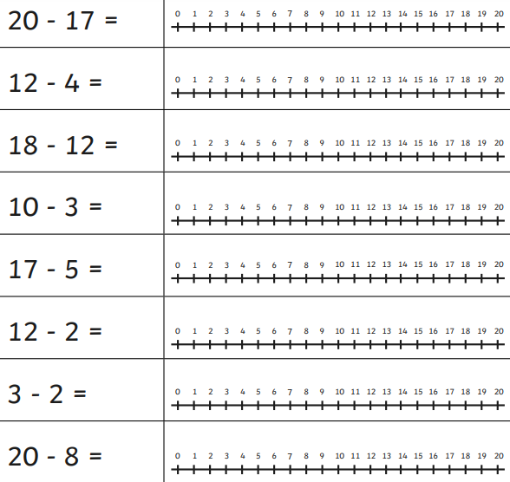
Use the number line to count backwards and solve the simple subtraction. Remember to start with the biggest number and count backwards.

