1JD  1/2RB | Reading | Writing | Maths | Topic
Monday | Read your reading book or choose one on Oxford Owl. You could also listen to a storyline online – use the link  https://www.storylineonline.net/ | Handwriting:  I, J, K, L  Capital letters practise, this is continued from remote learning.  Challenge: Think of a name that starts with each letter and write it down. | LO: Add by making 10 (practically).  Show how you can add using ten frames. Show making ten first. Only use 2 different colours as this will aid them tomorrow.  i.e. 7 + 4 =  Put 7 counters of the same colour.  Then add 4 in another counter.  Point out how the 4 has split into a 3 (to make the ten) and a 1.  Continue with examples.  6 + 5 is the same as 10 + _____  They both equal _____ | Paws Claws and Whiskers:  Group animals.  - Appearance (what they look like – wing/fur/scales)  - What they eat  - Where they live
Tuesday | Read your reading book or choose one on Oxford Owl. | English:  LO: To experience the story.  Listen to the story, either read to the children or on the link on You Tube. Then have 4 stations set up explain these stations to the children.  https://youtu.be/Rm3JsewQIWw  Children to:  Explore different role play stations make puppets.  Ask questions to a character.  Answer some questions  Act out some of the story. | LO: Add by making 10 (fill in the gaps)  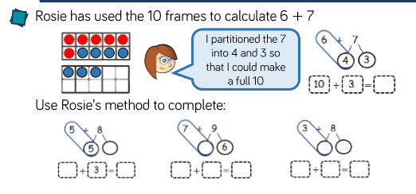  Step 1: Do the addition using 2 different colours.  Step 2: write what the second number has been split into (making sure the first number is the part on the full ten frame)  Step 3: complete the 10 + ___ = ____  Continue with examples and children making their own ten frames with counters. | PE  You tube- Cosmic Yoga, Joe Wicks workouts for kids.
Wednesday | Read your reading book or choose one on Oxford Owl. | Walk around the local area and write a list of all the different animals that you can see – the lake has some interesting birds – maybe you could find out some of their names. | LO: Subtraction – Pictorially.  Explain they are going to do their own subtractions.  Show children how to solve using pictures.  13 – 5 =  Continue with examples. | Paws, Claws and Whiskers:  What animals are  Carnivores  Herbivores  Omnivores
Thursday | Practise reading the red and green words.  See how speedy you can get. | Handwriting:  M, N, O, P  Capital letters practise, this is continued from remote learning.  Challenge: Think of a country or a place that starts with each letter and write it down. | LO: Subtraction – Number line.  Write “There were 16 ducks in a pond. 9 flew away. How many are left?”  Ask children. How we could solve this on a number line? Explaining why we start at/go back so many jumps etc.  Continue with examples. | Arts and Crafts:  Mother’s Day Card:  Make either a Mother’s Day Card or make a very special person card.  It could be for  Dad, Nana/Granny/Grandma, Grandad, you could even make one for a sibling – show them that you love them.
Friday | Choose 3 green words and put them into a sentence. | LO: To write a character description.  Write a character description with the children using the adjectives that they have scribed with the adult.  Make sure that recapping punctuation and knowing that names need CL’s.  Re-read back when writing and sound out some of the hard words. | Maths with Parents – Sign up and have a go online.  Make sure that you remember to add photos of you doing it with your parents. | RE:

