Friday 26th March 2021
Dear Parents and Carers,
School closes today for two weeks and reopens on Monday 12th April. It’s now just over a year since schools were closed for the first national lockdown. It seems strange to think that it has been such a long time and what has happened in these twelve months. From remote learning, zooms, partial closures, staggered starts and dinnertimes to bubbles, rainbows, clapping for the NHS and all the different ways we have had to do things it has certainly been a challenging but a successfully navigated year. For some children and families, the experience of the last 12 months was different - and even fun at times - but for others it was much more difficult. We have been reflecting too on all the loved ones who have been taken from us before their time.
I am not sure if you have seen it already, but Doncaster has launched a campaign to create a permanent memorial to honour the efforts of key workers, as well as providing a lasting memorial of those in our communities who have died of COVID-19 during the pandemic. The proposed statue (see below), which will stand nine feet tall, is being coordinated by Team Doncaster and will take pride of place within the centre of the town. It is hoped that, once complete, it will provide a suitable monument to the impact of the pandemic locally so that residents, as well as later generations, can reflect upon the handwork, sacrifice and loss experienced throughout 2020 and into 2021 as COVID-19 swept across the borough.

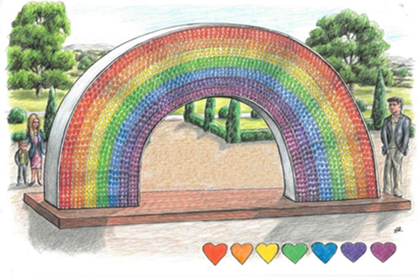
Local people will have the opportunity to get involved by donating a coloured heart which will be fixed to the monument making up the colours of the rainbow. Each will also bear a brief dedication to friends, family and loved ones, either in recognition of their efforts throughout the 12-month period, or instead in loving memory of someone sadly taken before their time.

You can dedicate a heart using the link here: Hearts for Doncaster - Doncaster and Bassetlaw Teaching Hospitals (dbth.nhs.uk)

School updates
Please make sure you notify school if your child tests positive with Covid over the holidays and particularly within 48 hours of school closing or reopening on Monday 12th April.
Next term, the arrangements we currently have in place, including staggered starts/finishes, bubbles etc. will continue and are likely to stay the same for the whole of Summer term. However, I will send an update to parents about this before the end of the first week back after the holidays.
There will no lessons over the holiday period but Doncaster Council have put together lots of exciting resources and activities here
Thank you for your very generous donations towards the Easter Raffle and Comic Relief. The raffle raised £1150 and we sent £171 to Comic Relief. More updates about the defibrillator will be sent next term.
We have also recently received kind donations from Doncaster Rotary Club and Joe Booth Aggregates which have gone towards creating the school garden and a new kitchen in the Lakeside Community Hub. This will be used for cooking lessons for children and Cook and Eat sessions for families, hopefully using some of the fresh produce we will be growing in the garden.
Because of Covid restrictions we have not been able to make full use of the Hub this year but we have lots of exciting projects in the pipeline ready to start as soon as we are able to.
There are still places in Nursery for early starters and for September. The new Early Years unit is a fantastic environment for children to learn and grow, please encourage any friends or family you have in Doncaster to come and visit us if they are still looking for places.
Finally, we wish all our children and families a very Happy Easter and a restful holiday break.

Yours sincerely,

Mr. J Bullock
Head Teacher

